**Assignment 2: Debugging Vision Transformers (ViT) with PyCharm and WSL**

**Introduction**

For this assignment, I used **PyCharm + WSL (Ubuntu 24.04)** to debug a Vision Transformer (ViT). The model used was the standard **vanilla ViT-B/16** configuration: patch size = 16, embedding dimension = 768, 12 attention heads, 12 encoder blocks, and a classification head for 1000 ImageNet classes. This setup allowed step-by-step inspection of all tensors through the forward pass.

**Environment Setup**

PyCharm was configured to use WSL as the Python interpreter. Transformer code was executed and debugged successfully inside PyCharm. The debugger was used instead of print statements, as required.

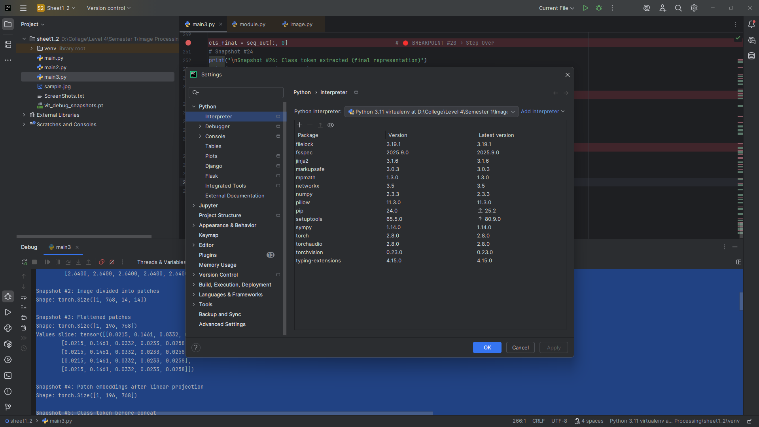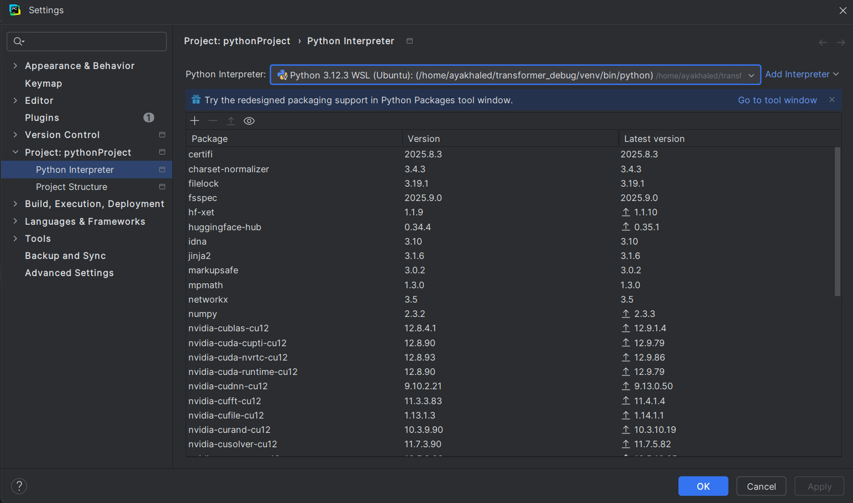

**Input Image & Preprocessing**

* **Selected Image:** sample.jpg
* 
* **Source:** personal photo
* **Preprocessing Steps:**
  1. Convert image to RGB.
  2. Resize to 224 × 224.
  3. Normalize using ImageNet mean [0.485, 0.456, 0.406] and std [0.229, 0.224, 0.225].
  4. Convert to tensor with shape (1, 3, 224, 224).

**Snapshots**

**Input and Patchification**

**Snapshot #1 – Raw Input Image Tensor  
Shape:** torch.Size([1, 3, 224, 224])

**Values slice:** tensor([[[2.2489, 2.2489, 2.2489, 2.2489, 2.2489],

[2.2489, 2.2489, 2.2489, 2.2489, 2.2489],

[2.2489, 2.2489, 2.2489, 2.2489, 2.2489],

[2.2489, 2.2489, 2.2489, 2.2489, 2.2489],

[2.2489, 2.2489, 2.2489, 2.2489, 2.2489]],

[[2.4286, 2.4286, 2.4286, 2.4286, 2.4286],

[2.4286, 2.4286, 2.4286, 2.4286, 2.4286],

[2.4286, 2.4286, 2.4286, 2.4286, 2.4286],

[2.4286, 2.4286, 2.4286, 2.4286, 2.4286],

[2.4286, 2.4286, 2.4286, 2.4286, 2.4286]],

[[2.6400, 2.6400, 2.6400, 2.6400, 2.6400],

[2.6400, 2.6400, 2.6400, 2.6400, 2.6400],

[2.6400, 2.6400, 2.6400, 2.6400, 2.6400],

[2.6400, 2.6400, 2.6400, 2.6400, 2.6400],

[2.6400, 2.6400, 2.6400, 2.6400, 2.6400]]])

**Explanation:** Batch of size 1, 3 channels (RGB), resized to 224×224.

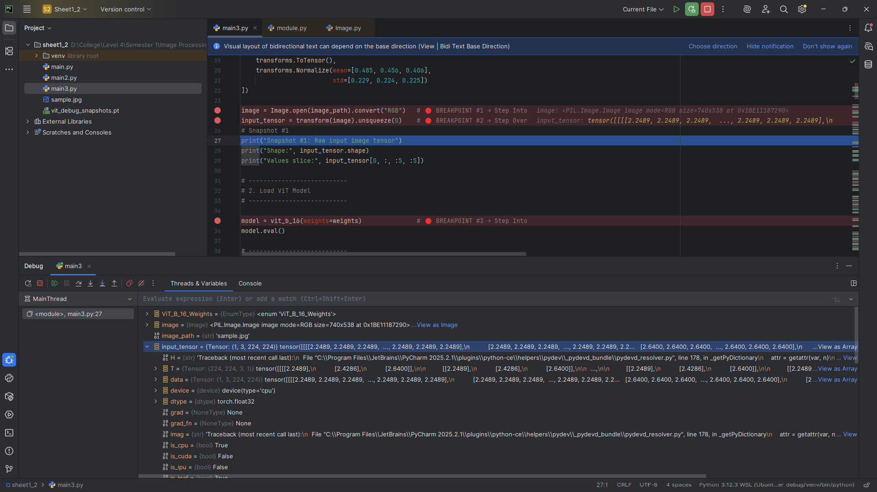

**Snapshot #2 – Image Divided into Patches  
Shape:** torch.Size([1, 768, 14, 14]) **Explanation:** The image is split into non-overlapping 16×16 patches, each represented as a 3×16×16 tensor (flattened later).

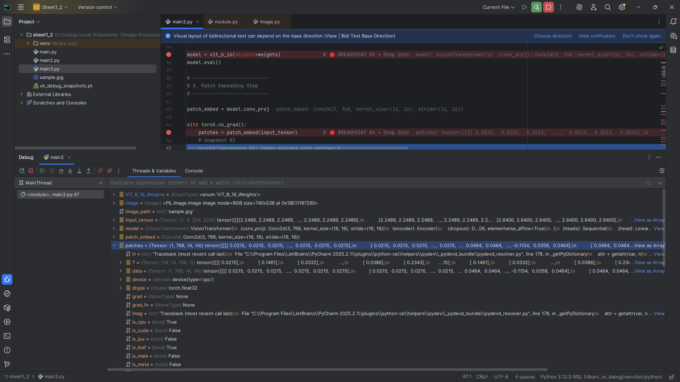

**Snapshot #3 – Flattened Patches  
Shape:** torch.Size([1, 196, 768])

**Values slice:** tensor([[0.0215, 0.1461, 0.0332, 0.0233, 0.0258],

[0.0215, 0.1461, 0.0332, 0.0233, 0.0258],

[0.0215, 0.1461, 0.0332, 0.0233, 0.0258],

[0.0215, 0.1461, 0.0332, 0.0233, 0.0258],

[0.0215, 0.1461, 0.0332, 0.0233, 0.0258]])

**Explanation:** 14×14 = 196 patches, each flattened into a 768-dimensional vector.

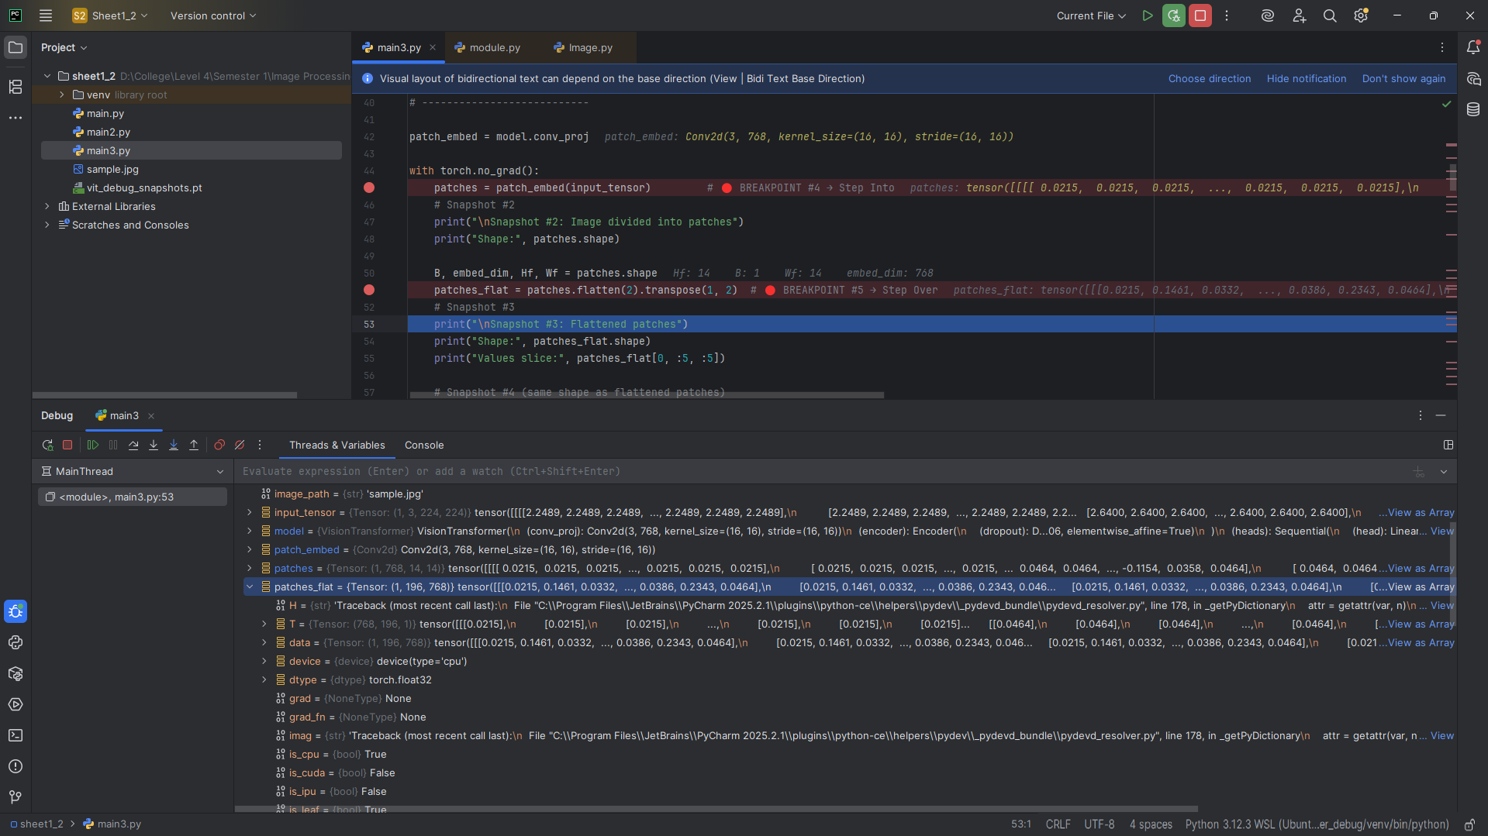

**Embedding and Tokens**

**Snapshot #4 – Patch Embeddings After Linear Projection  
Shape:** torch.Size([1, 196, 768]) **Explanation:** Each patch is projected linearly into the embedding space (768 dimensions).

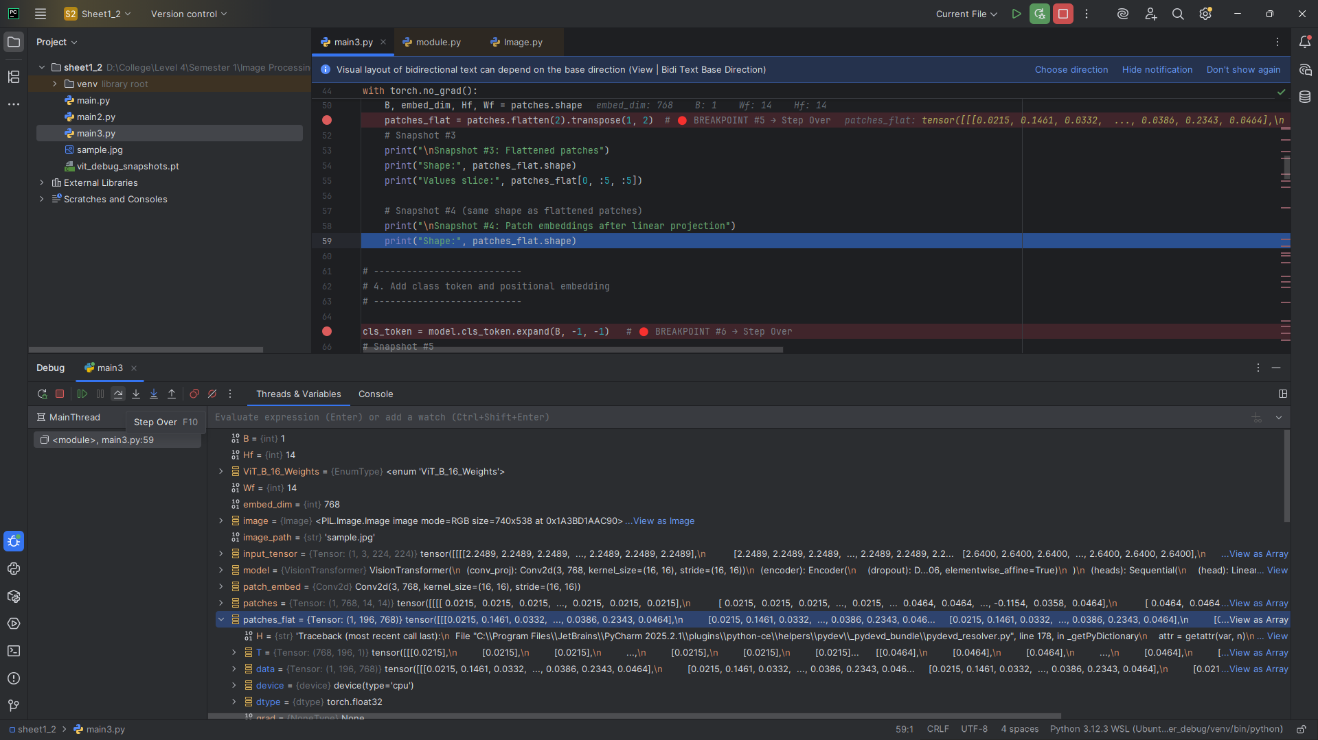

**Snapshot #5 – Class Token Before Concatenation  
Shape:** torch.Size([1, 1, 768])

**Values slice:** tensor([[-0.0012, 0.0027, 0.0025, -0.0010, -0.0007]],

grad_fn=<SliceBackward0>)

**Explanation:** A learnable class token is initialized for aggregation of patch information.

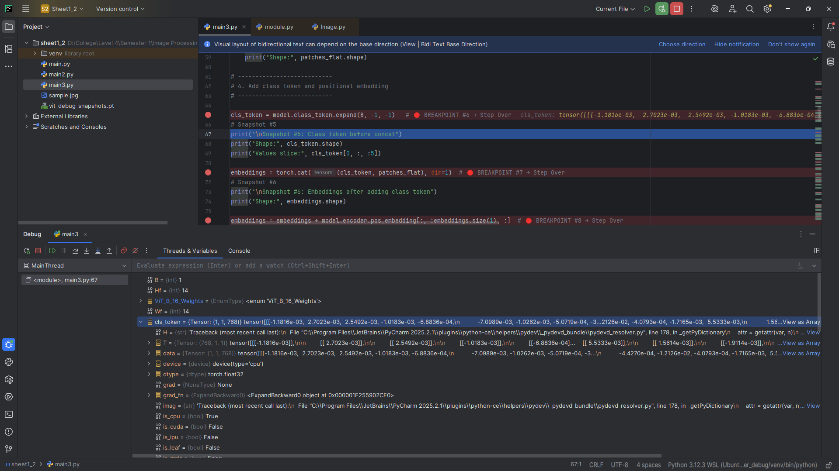

**Snapshot #6 – Embeddings After Adding Class Token  
Shape:** torch.Size([1, 197, 768]) **Explanation:** Class token prepended; total tokens = 196 + 1 = 197.

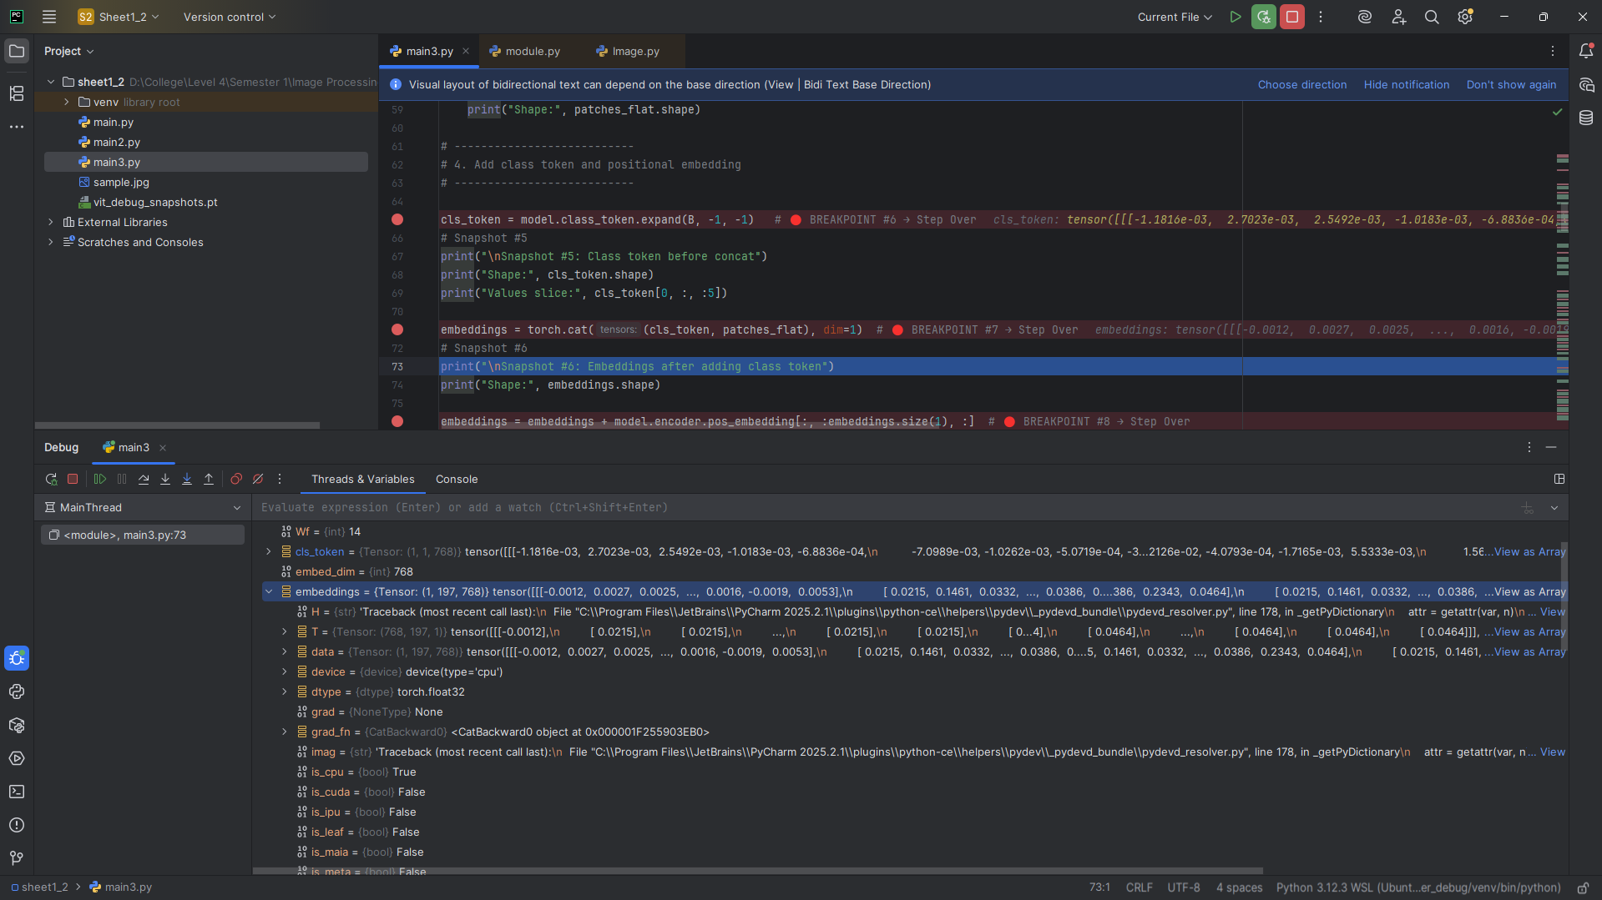

**Snapshot #7 – Embeddings After Adding Positional Encoding  
Shape:** torch.Size([1, 197, 768]) **Explanation:** Positional encodings added to each token to preserve spatial information.

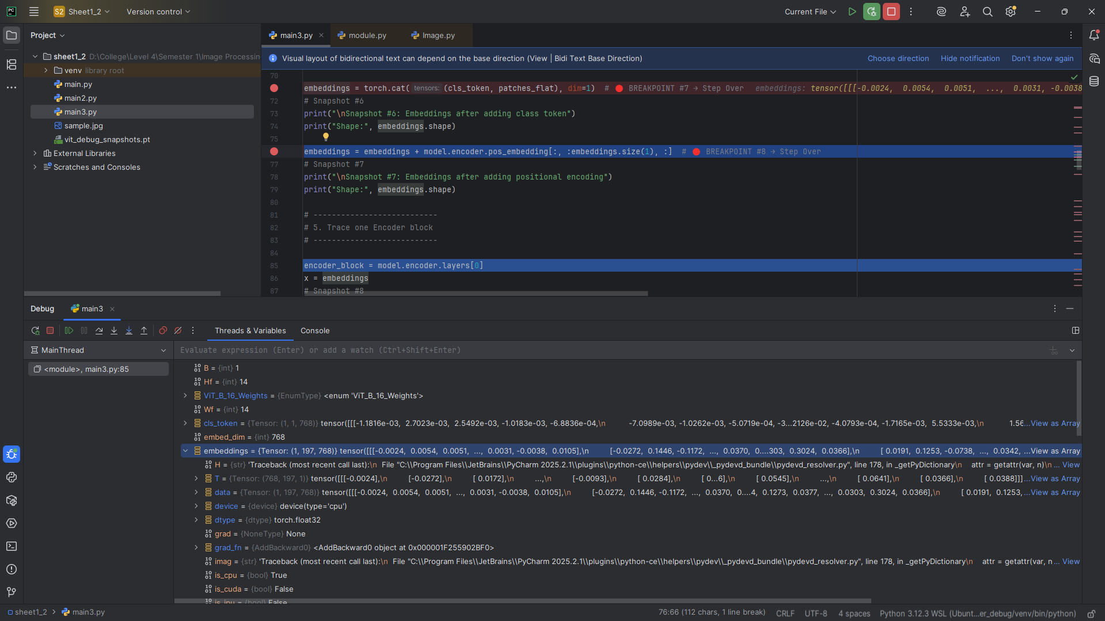

**Encoder Block (Trace One Block)**

**Snapshot #8 – Encoder Block Input Tensor  
Shape:** torch.Size([1, 197, 768])

**Values** slice: tensor([[-0.0024, 0.0054, 0.0051, -0.0020, -0.0014],

[-0.0272, 0.1446, -0.1172, 0.0054, -0.0189],

[ 0.0172, 0.1514, 0.0418, 0.0081, -0.0062]],

grad_fn=<SliceBackward0>)

**Explanation:** Input to first encoder block after embedding and positional encoding.

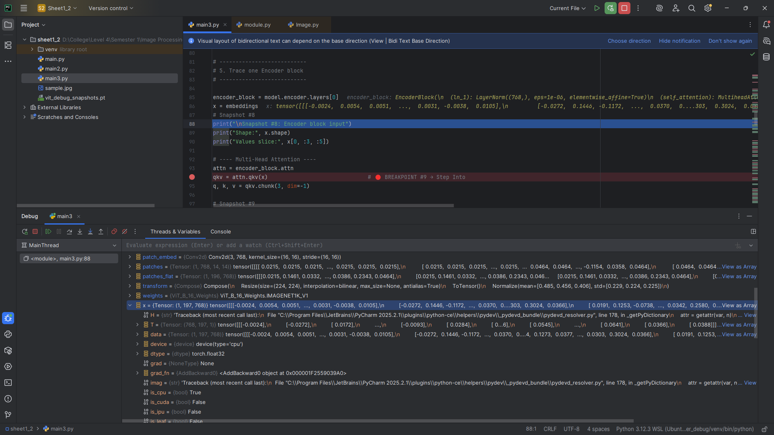

**Snapshot #9 – Queries Q  
Shape:** torch.Size([1, 197, 768])

**Values slice:** tensor([[ 0.2778, -0.1166, -0.1229, 0.0940, 0.2599],

[-1.1336, -1.5059, -1.4790, 1.3344, 0.6634],

[-1.1757, -1.4564, -1.4230, 1.2744, 0.5796]],

grad_fn=<SliceBackward0>)

**Explanation:** Q is computed via linear projection of input tokens for attention.

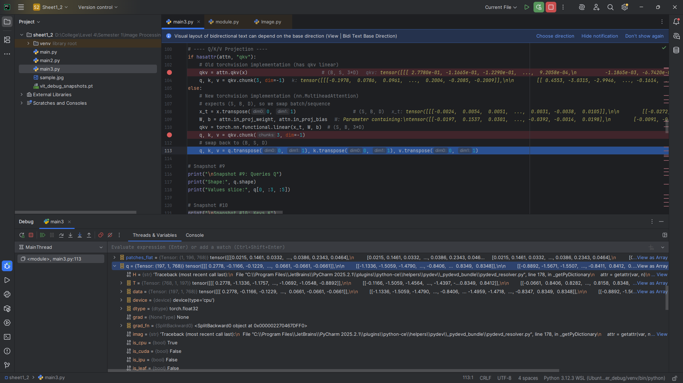

**Snapshot #10 – Keys K  
Shape:** torch.Size([1, 197, 768])

**Values slice:** tensor([[-0.1978, 0.0786, 0.0961, -0.1022, -0.1497],

[ 0.4553, -3.0315, -2.9946, 1.8674, 1.2165],

[ 0.4117, -3.0612, -3.0116, 1.8613, 1.1722]],

grad_fn=<SliceBackward0>)

**Explanation:** K is computed via linear projection; used to calculate attention scores.

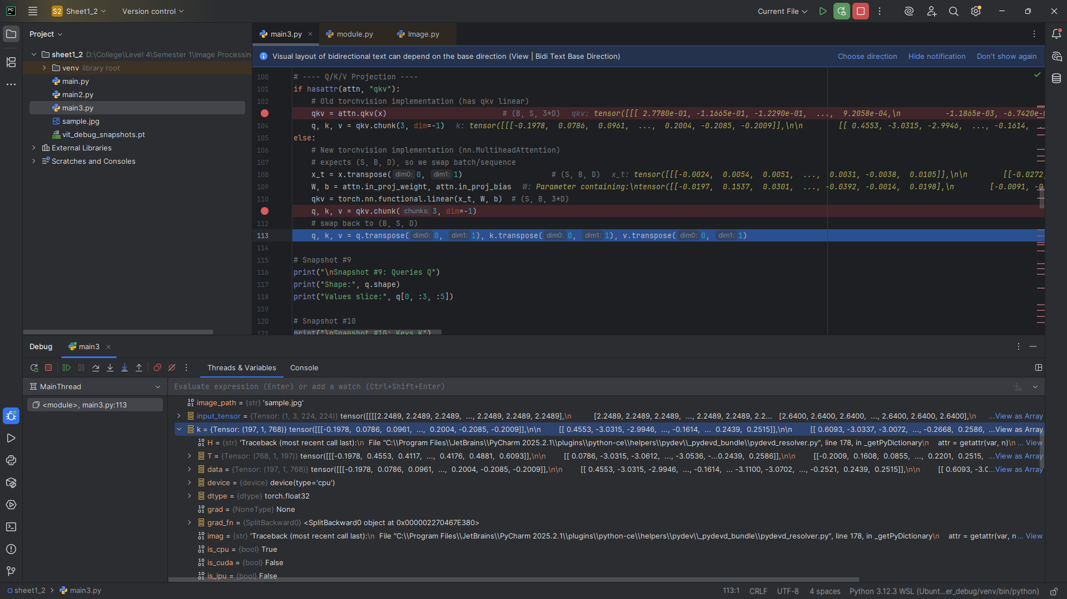

**Snapshot #11 – Values V  
Shape:** torch.Size([1, 197, 768])

**Values slice:** tensor([[-0.1273, -0.1968, -0.0663, 0.2673, -0.1724],

[-0.0062, 0.0186, 0.0107, -0.0100, 0.0038],

[-0.0029, 0.0237, -0.0227, -0.0087, 0.0069]],

grad_fn=<SliceBackward0>)

**Explanation:** V is computed via linear projection; weighted by attention for output.

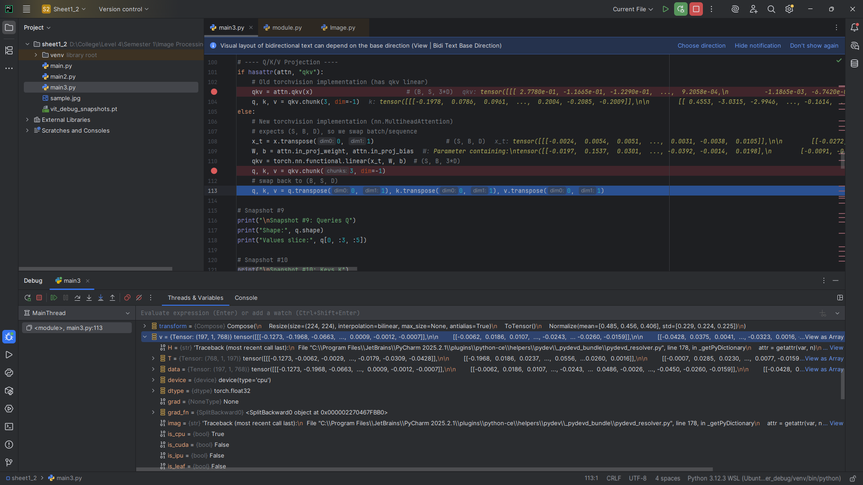

**Snapshot #12 – Attention Scores Before Softmax  
Shape:** torch.Size([1, 12, 197, 197])

**Values slice:** tensor([[-0.1313, 2.1769, 2.1670],

[-0.8051, 23.5277, 23.7567],

[-0.7547, 22.6490, 22.8875]], grad_fn=<SliceBackward0>)

**Explanation:** Raw attention scores computed as Q·K^T / √d_k for all heads.

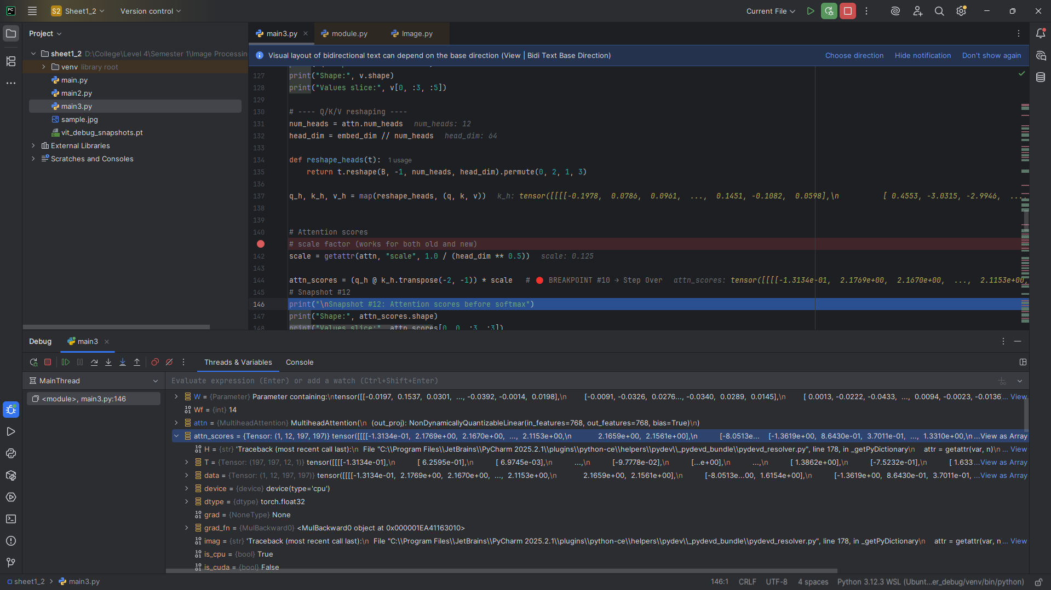

**Snapshot #13 – Attention Scores After Softmax  
Shape:** torch.Size([1, 12, 197, 197])

**Values slice:** tensor([[6.9647e-04, 7.0041e-03, 6.9354e-03],

[1.4343e-13, 5.2994e-03, 6.6633e-03],

[3.6739e-13, 5.3606e-03, 6.8050e-03]], grad_fn=<SliceBackward0>)

**Explanation:** Softmax normalizes attention scores to probabilities.

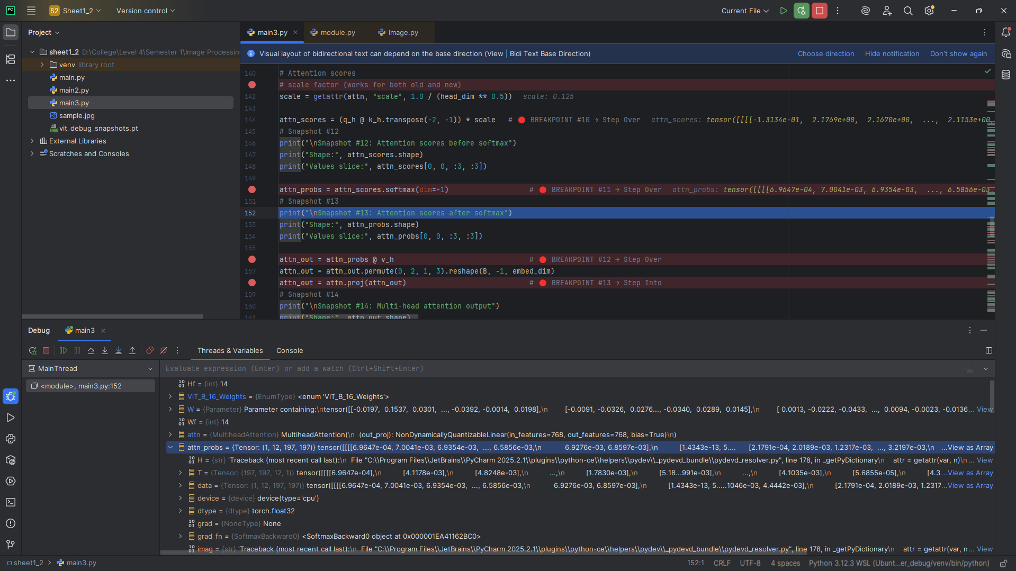

**Snapshot #14 – Multi-Head Attention Output  
Shape:** torch.Size([1, 197, 768]) **Explanation:** Concatenated output of all attention heads.

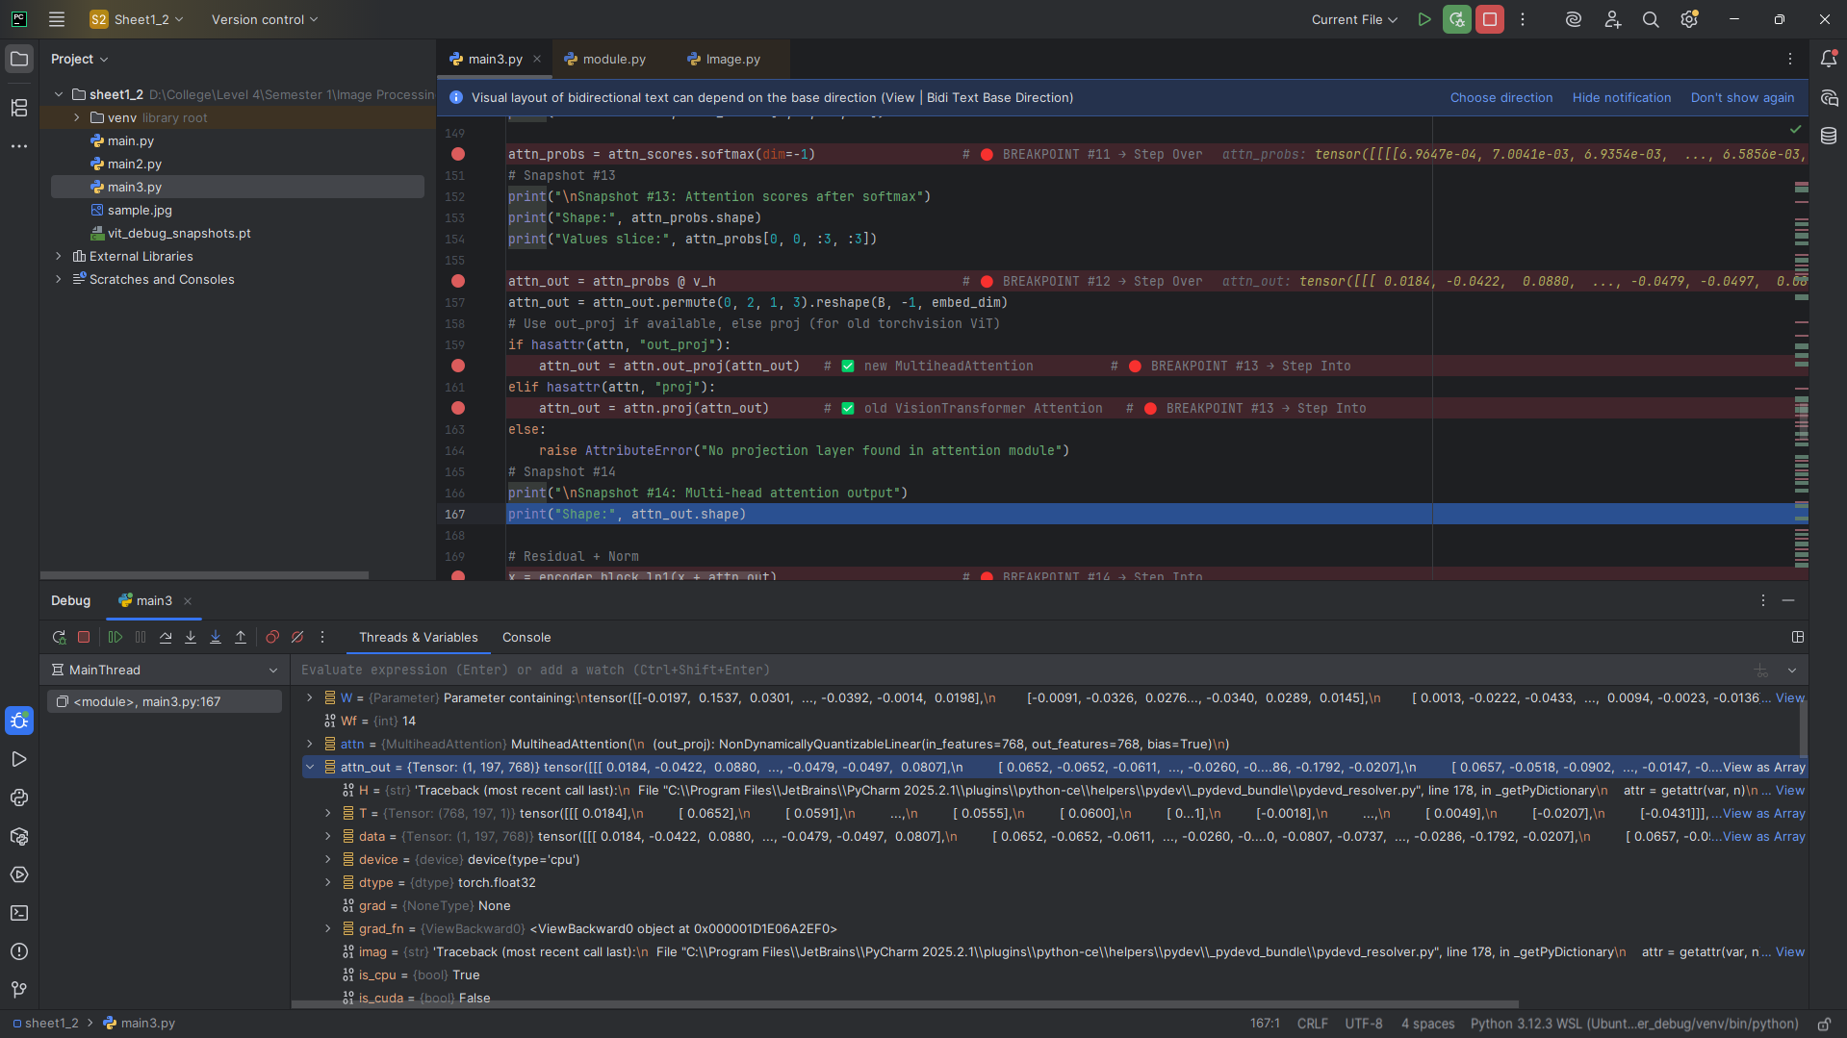

**Snapshot #15 – Residual Connection + Norm (Post-Attention)  
Shape:** torch.Size([1, 197, 768])  
**Explanation:** Residual added to input and normalized to stabilize training.

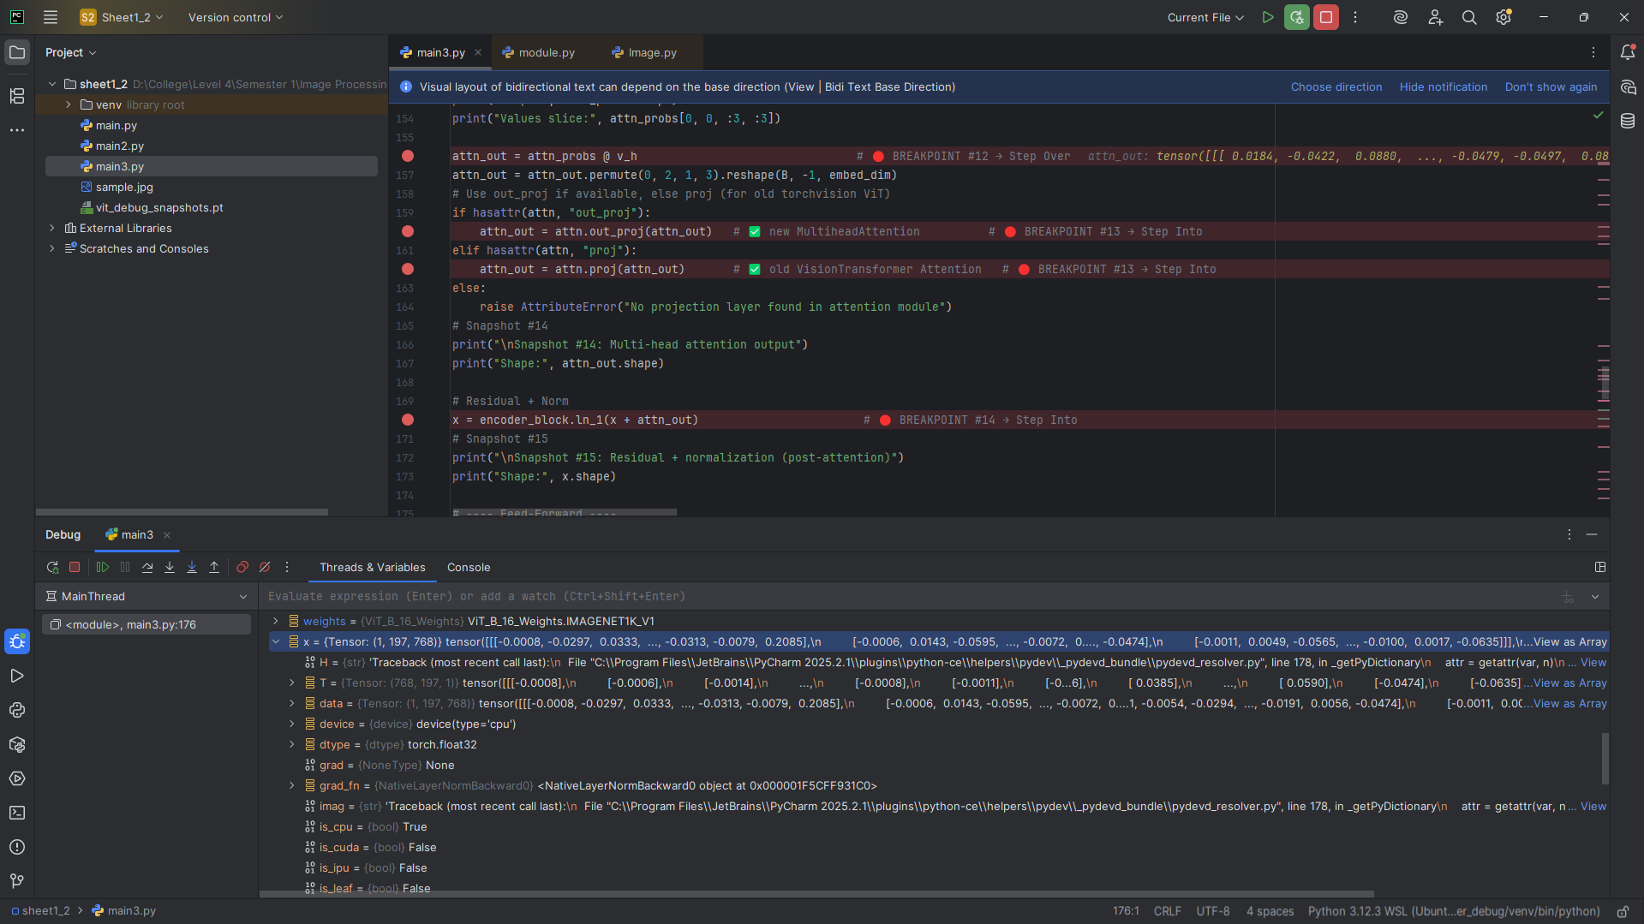

**Snapshot #16 – Feed-Forward Input  
Shape:** torch.Size([1, 197, 768]) **Explanation:** Input for MLP inside encoder block.

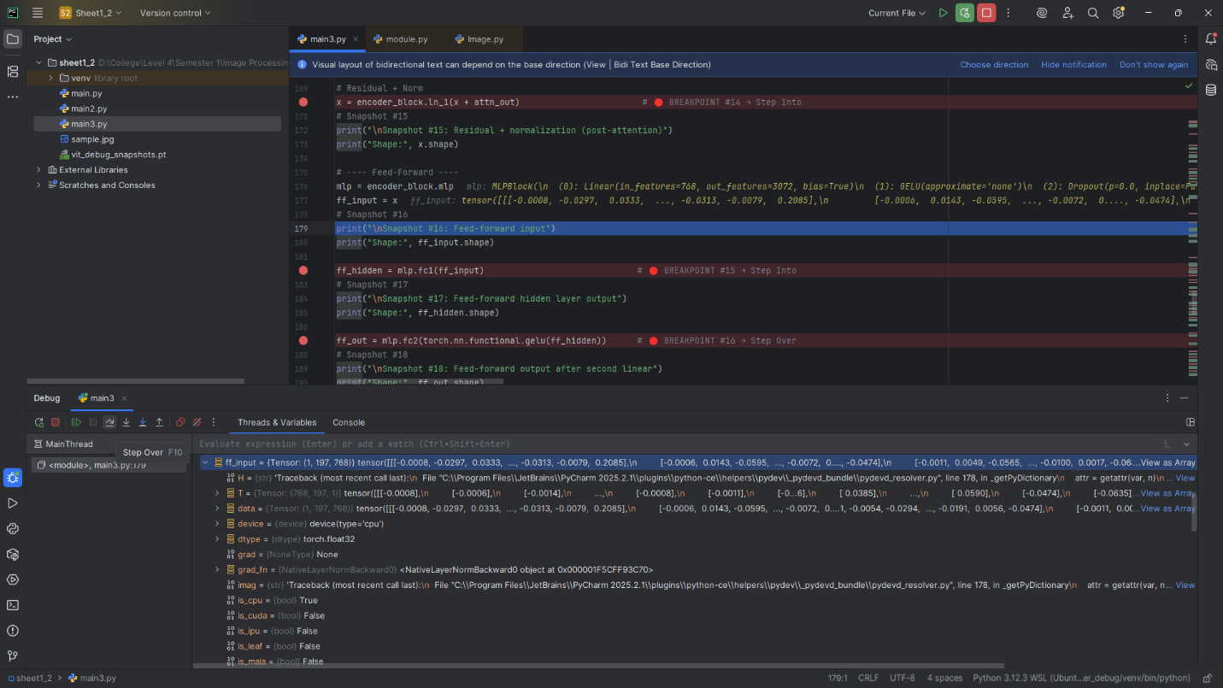

**Snapshot #17 – Feed-Forward Hidden Layer Output  
Shape:** torch.Size([1, 197, 3072]) **Explanation:** Hidden layer expanded 4× embedding dimension.

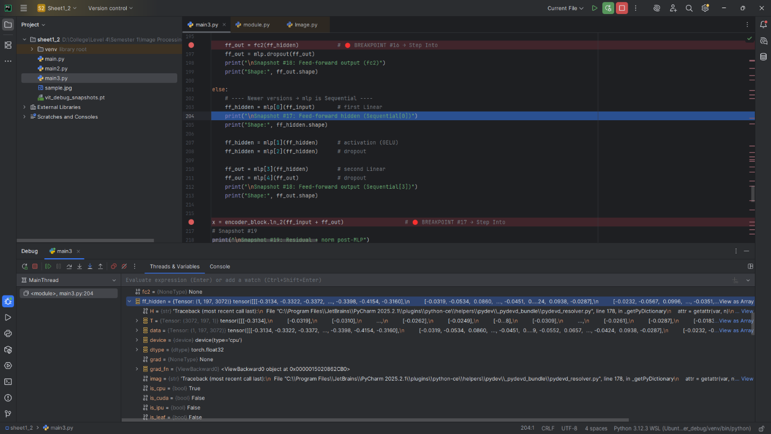

**Snapshot #18 – Feed-Forward Output After Second Linear  
Shape:** torch.Size([1, 197, 768]) **Explanation:** Projected back to embedding dimension.

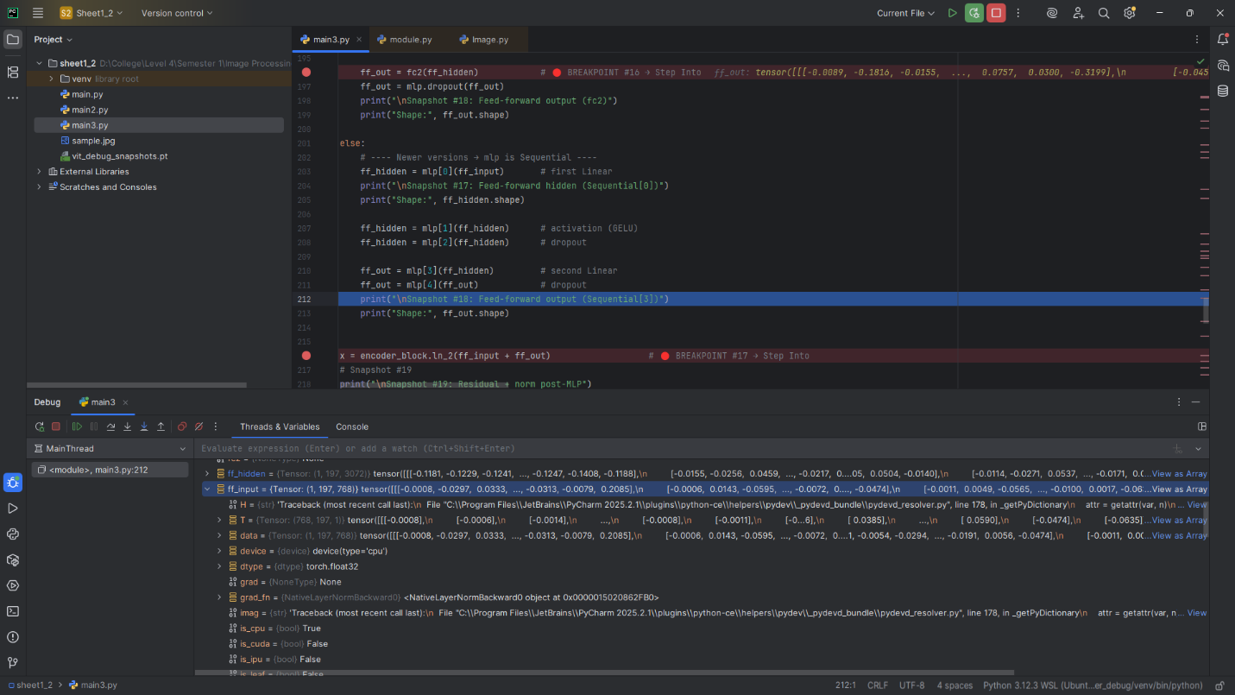

**Snapshot #19 – Residual + Norm Post-MLP  
Shape:** torch.Size([1, 197, 768]) **Explanation:** Residual connection ensures consistent token shape.

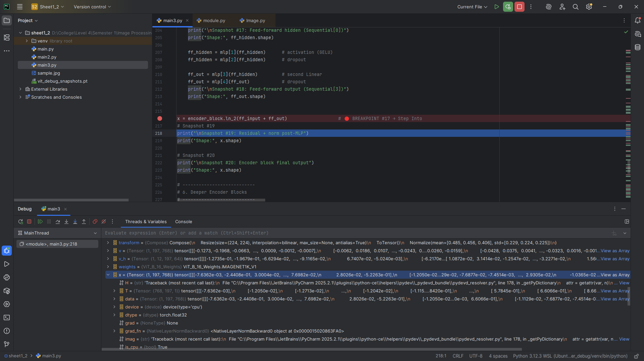

**Snapshot #20 – Encoder Block Final Output  
Shape:** torch.Size([1, 197, 768])

**Explanation**: First, encoder block outputs tokens with same shape, refined representations.

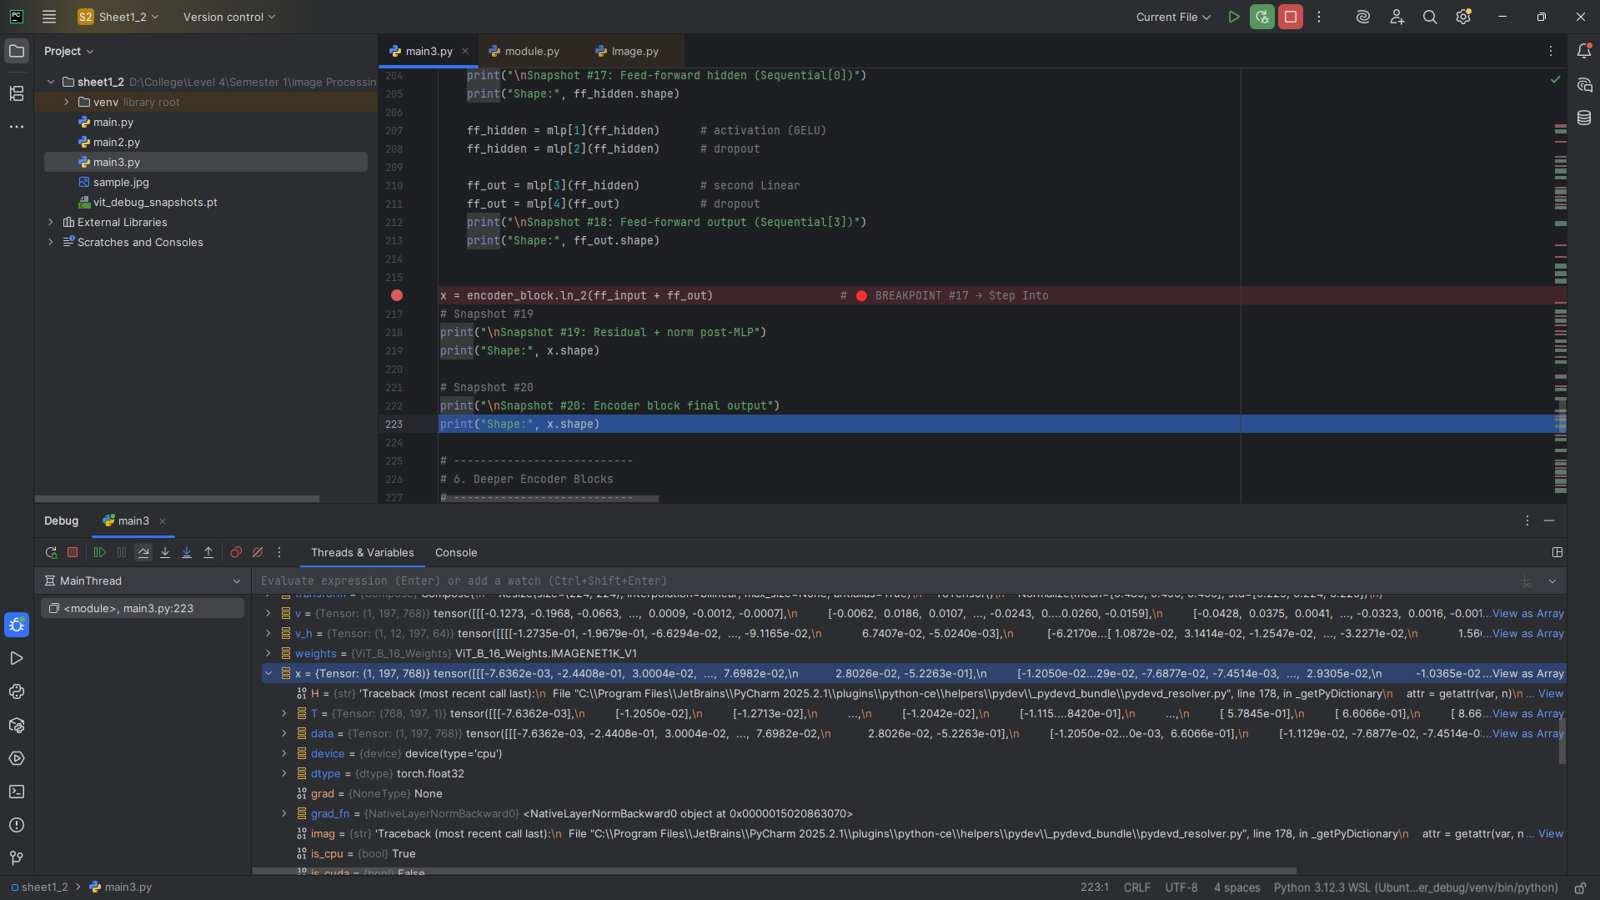

**Deeper Encoder Blocks**

**Snapshot #21 – Encoder Block 2 Output  
Shape:** torch.Size([1, 197, 768])

**Explanation:** Shape remains [1, 197, 768]; deeper attention captures richer relations.

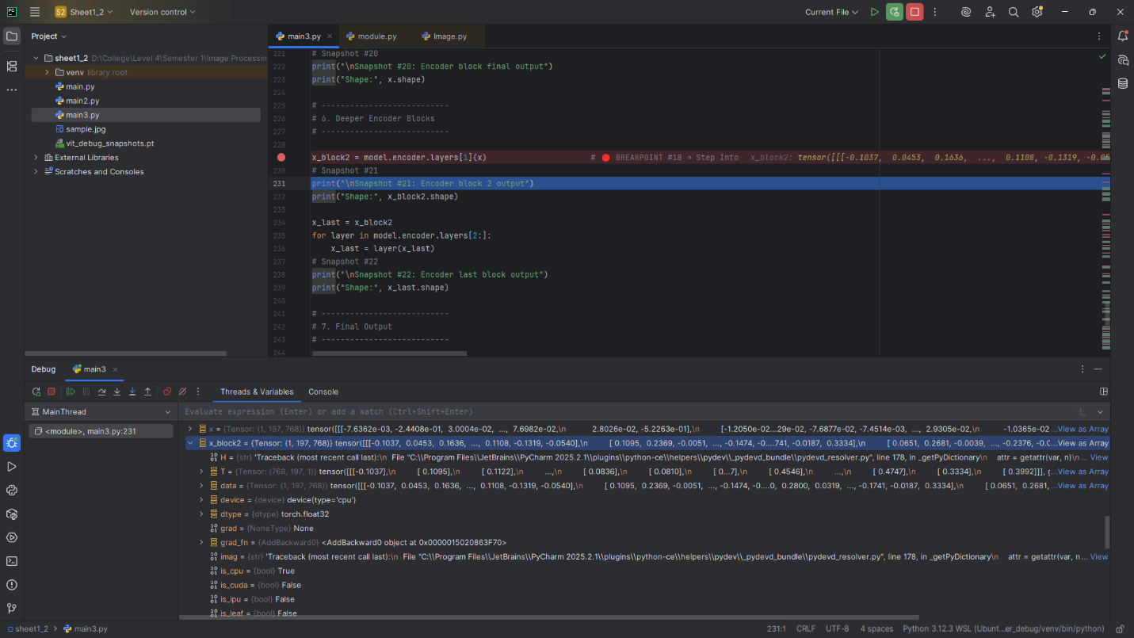

**Snapshot #22 – Encoder Last Block Output  
Shape:** torch.Size([1, 197, 768])

**Explanation**: After 12 blocks, shape is unchanged but representations are highly abstract.

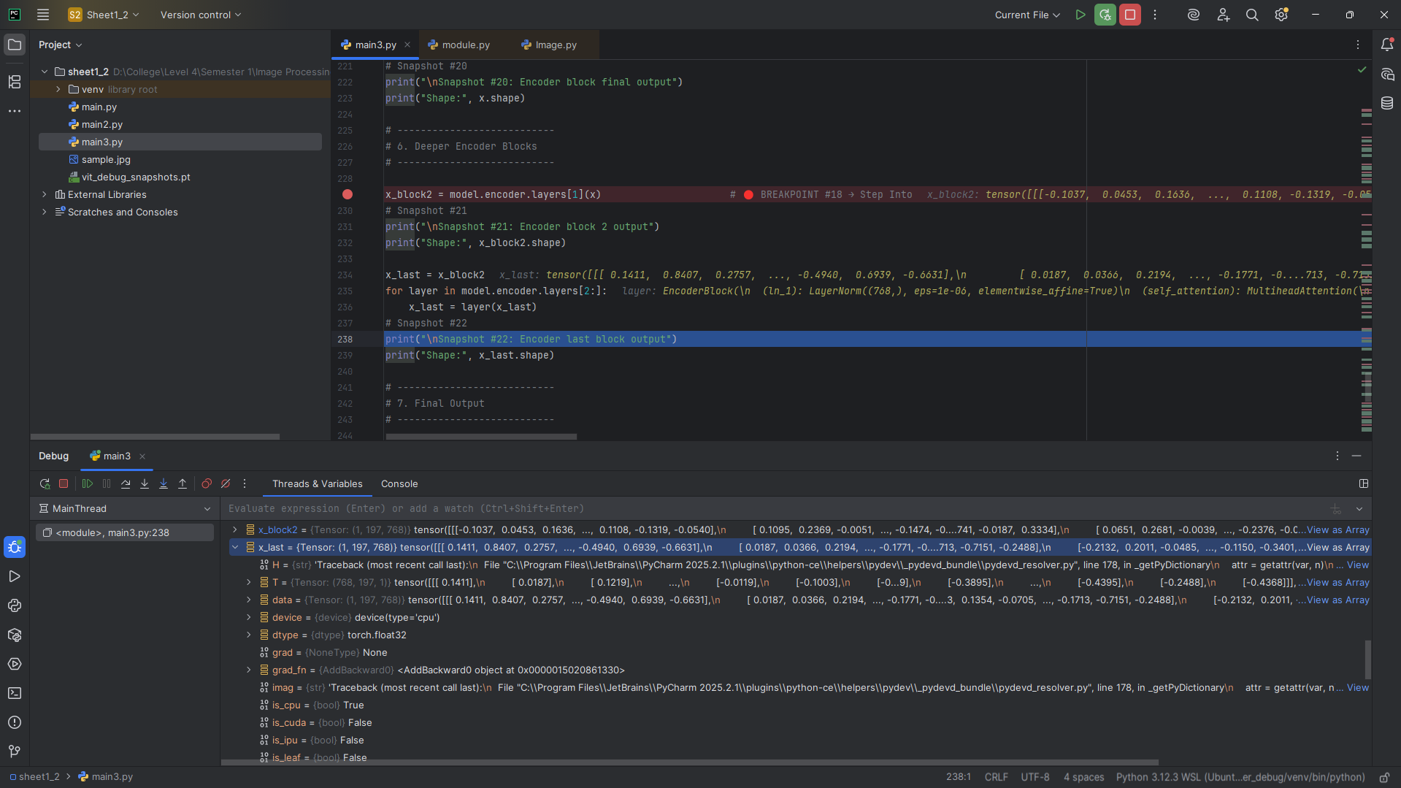

**Final Output**

**Snapshot #23 – Final Sequence Output (Including Class Token)  
Shape:** torch.Size([1, 197, 768])

**Explanation**: Sequence still has 197 tokens; class token will be used for classification.

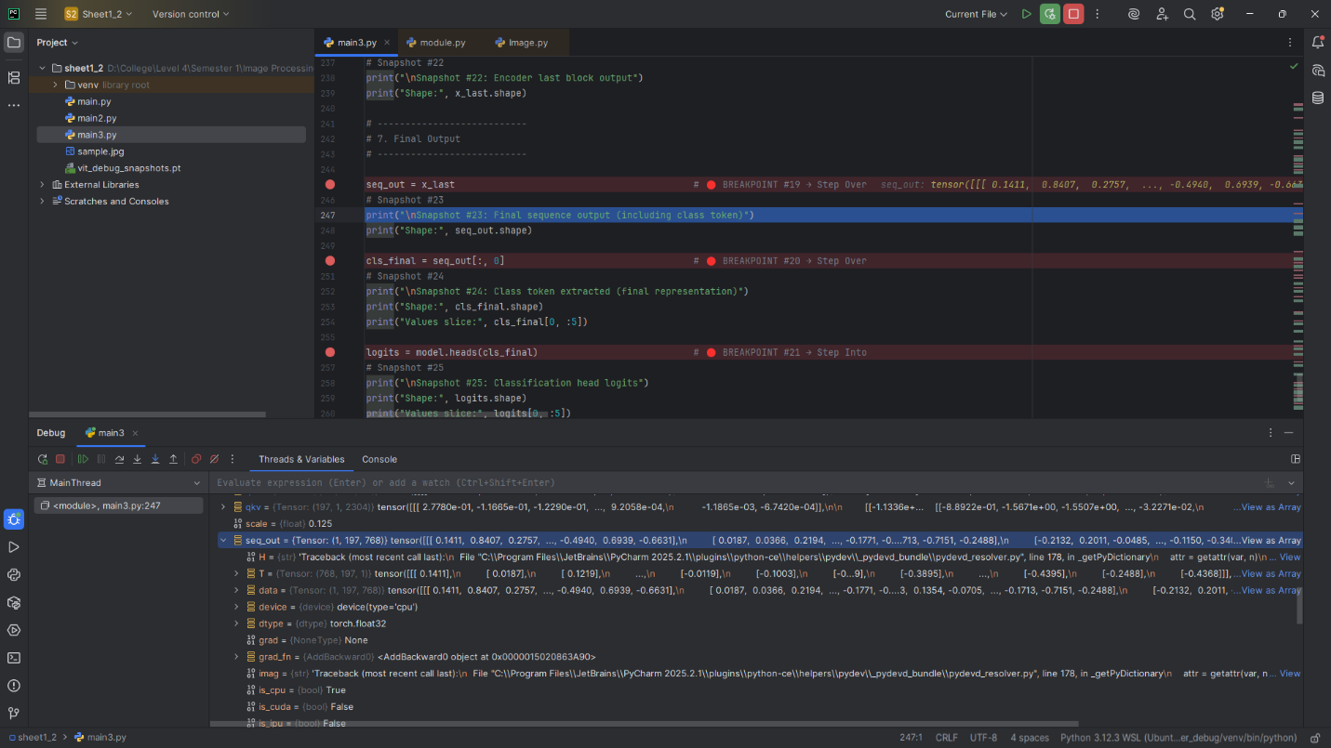

**Snapshot #24 – Class Token Extracted  
Shape:** torch.Size([1, 768])

**Values slice:** tensor([ 0.1411, 0.8407, 0.2757, 0.3555, -0.0191], grad_fn=<SliceBackward0>)

**Explanation:** Class token selected as summary representation.

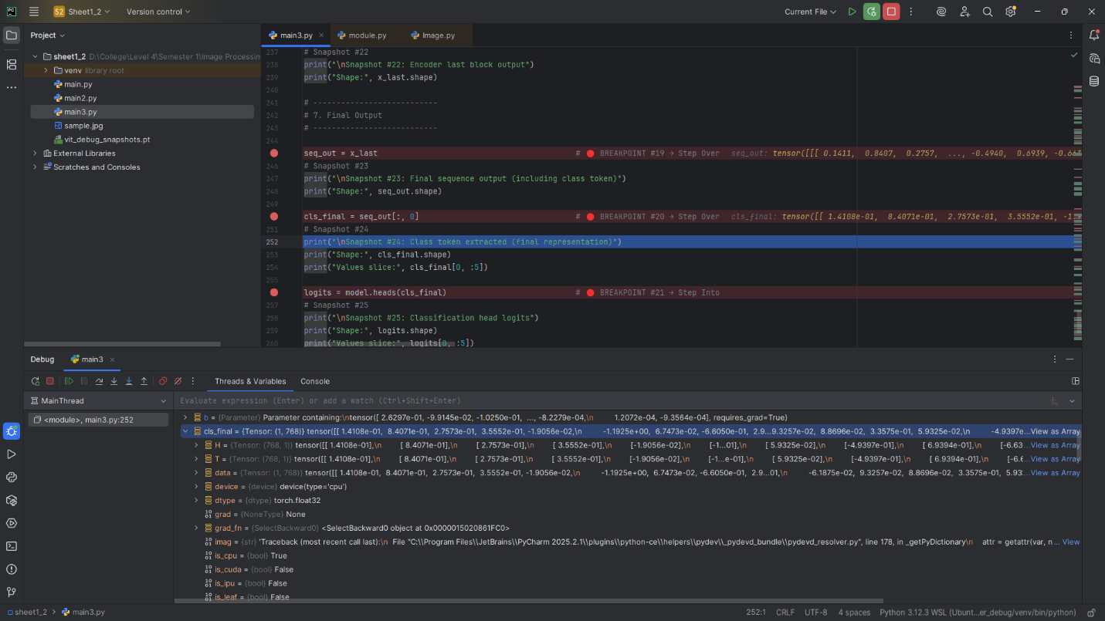

**Snapshot #25 – Classification Head Logits  
Shape:** torch.Size([1, 1000])

**Values slice:** tensor([0.8927, 0.8143, 0.8557, 2.1079, 0.5040], grad_fn=<SliceBackward0>)

**Explanation:** Linear projection of class token to ImageNet logits.

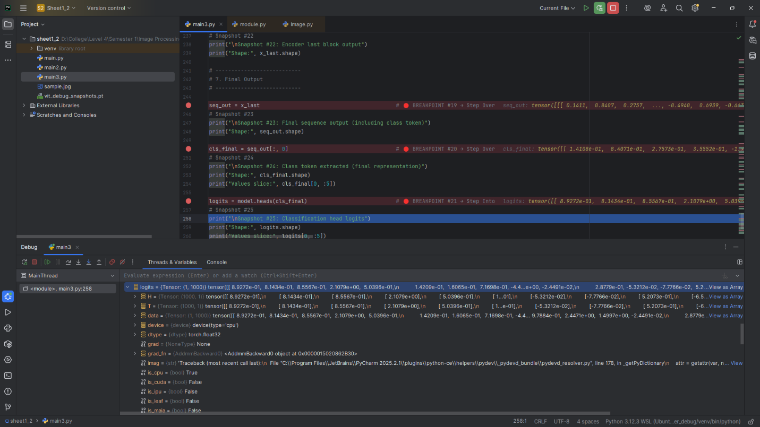

**Snapshot #26 – Softmax Probabilities  
Shape:** torch.Size([1, 1000])

**Values slice:** tensor([0.0014, 0.0013, 0.0014, 0.0049, 0.0010], grad_fn=<SliceBackward0>)

**Explanation:** Normalized probabilities for each class.

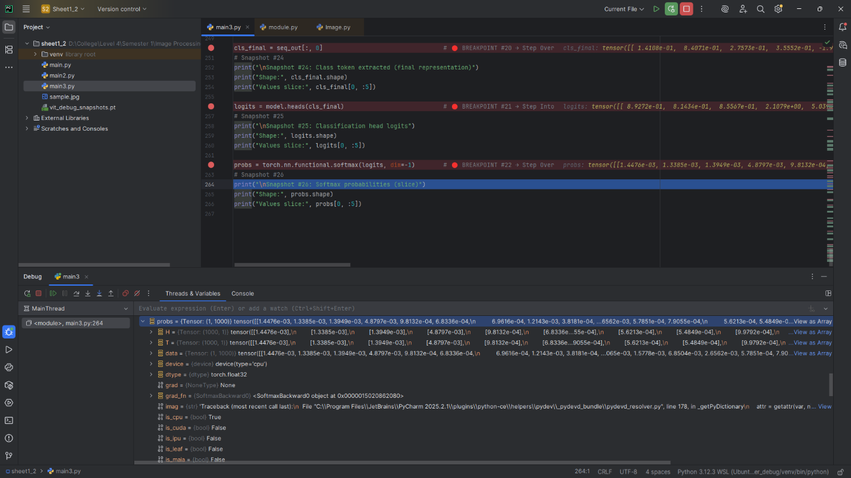

**Guiding Questions**

1. **Why split image into patches?**
   * Transformers operate on sequences, so patches turn the 2D image into a 1D token sequence.
2. **Why add a class token?**
   * Aggregates information from all patches; final classification only uses this token.
3. **Why positional encodings?**
   * Transformers are permutation-invariant; positional encodings provide spatial information.
4. **Why Q, K, V same dimension?**
   * Ensures compatible matrix multiplication for attention; attention weights scale with token count (num_patches + 1).
5. **Residual connections preserve shape?**
   * They allow the input shape to match output, stabilizing deep stack of blocks.
6. **Why only class token for final classification?**
   * It summarizes all patch information; avoids using every patch separately.

**Reflection**

Debugging each step allowed me to see how patches transform into embeddings, how attention works across tokens, and how residual connections stabilize the network. It greatly improved my intuition for how ViTs process images and why specific design choices (class token, positional encoding) are critical.